

BASIC PATTERNS IN UFO OBSERVATIONS
Claude Poher* and Jacques Vallee**

Abstract
This paper presents the view that (1) a significant proportion of the thousands of UFO reports analyzed by the authors come from witnesses who have really observed an object in the sky or at ground level; (2) the objects these witnesses have seen have characteristics very different from all identifiable objects and phenomena; (3) the phenomenon is of high scientific interest; and (4) a systematic research approach can be defined.
These conclusions are based on many years of research into the phenomenon, in the course of which the authors have had at their disposal the official Air Force files of the United States and of France, as well as files of several reliable private organizations. The paper presents the results of computer statistics obtained independently, and it describes some correlations between geomagnetic disturbances and UFO observations.

*Dr. Claude Poher is a member of the Scientific Projects Division, Centre National d'Etudes Spatiales, Toulouse (France). He holds a Ph.D in astrophysics and has been a pilot for 20 years.
**Dr. Jacques Vallee is the principal investigator of a computer research project in the United
States and a member of the Scientific Advisory Board of the Center for UFO Studies, Evanston (Illinois). He holds an M.S. in astrophysics and a Ph.D. in computer science.

Introduction

"There has been an extremely impressive increase In the number of visual sightings of luminous phenomena, sometimes spherical, sometimes ovoid, traveling at extraordinarily high speeds. . . . ' My own profound belief is that it is necessary to adopt an extremely open-minded attitude towards these phenomena. Man has made progress because he has sought to explain the inexplicable. . ."
Robert Galley, French Defense Minister
France-Inter broadcast, 21 February 1974 (2)

During 1973 and early 1974, there has been a remarkable recurrence of a type of phenomenon known as a "wave" of unidentified flying objects. Coming as it did less than four years after the closing of Project "Blue Book" by the U.S. Air Force (1), this series of observations has prompted a new scientific debate concerning the reality of the objects or craft responsible for triggering the reports. Accordingly, we have examined the files of UFO observations in France and in the United States in the light of the following questions:

- Have the witnesses really seen something?

The first parameter to consider in a study of visual observations is that of weather conditions. Fully 25 percent of the reports examined in official French files contain information about meteorological conditions as reported by witnesses. This information was found to agree very well with weather data for the same times and places as obtained from official sources.
A simple statistical result (based on 258 reports) indicates that the phenomenon is seen less frequently as the weather conditions worsen. The statistics were computed separately for French and non-French cases and found to be in excellent agreement, with about 57 percent of all reports being made under clear sky conditions, 15 to 20 percent under scattered cloud conditions, 10 percent under high overcast, 8 percent under low overcast, and the remaining few percentage points coming from observations in rain or snow.
Using a term familiar to pilots, we consider the "visibility distance" (V) to be the maximum distance at which an aircraft is visible in the atmosphere . When we plot the number of reports as a function of this measure of atmospheric transparency, we find (Figure 1) a curve in good agreement with the model of the human vision for equidistributed luminous objects in the atmosphere.

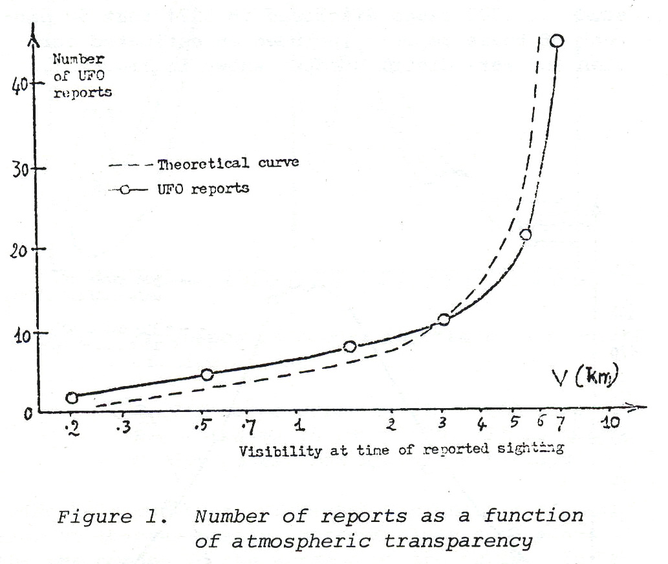

Another interesting result is obtained when we consider those unexplained reports (308 cases in the French files) in which angular elevation (h) is estimated by the observer and in which the object is of small angular diameter. Plotting on Figure 2 the number of reports against 1/sin h, we obtain a very good fit to the classical "Bouguer line" of optical astronomy (used in atmospheric absorption corrections).

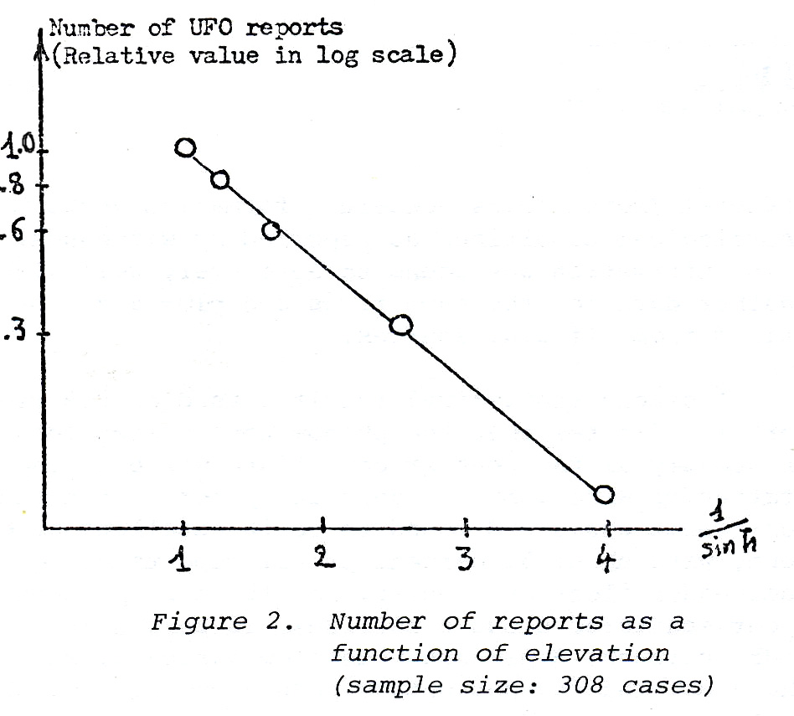

We conclude on this basis that the phenomenon under study presents the optical characteristics of a real physical phenomenon, observed by the witnesses' own eyes, through the imperfectly transparent atmosphere.

- Can the reports be explained by identifiable phenomena?

We have approached this question through a study of the reported duration of the observations. In a book (16) published in 1966, one of us has already called attention to the fact that "Manifestations of the UFO phenomenon were of considerable duration, often in excess of five minutes and commonly of fifteen or twenty minutes." A statistical study of 1,000 cases disclosed in 1974 that 50 percent of these reports included an estimated duration and were distributed as shown in Figure 3.

This curve corresponds in no way to the characteristic distribution for identifiable objects, which can be obtained as a composite of observations of meteors, balloons, stars, aircraft, birds, satellites, etc. In fact, when we plotted, on the same scale, 350 cases of explained reports (containing an estimated duration for phenomena that had been definitely

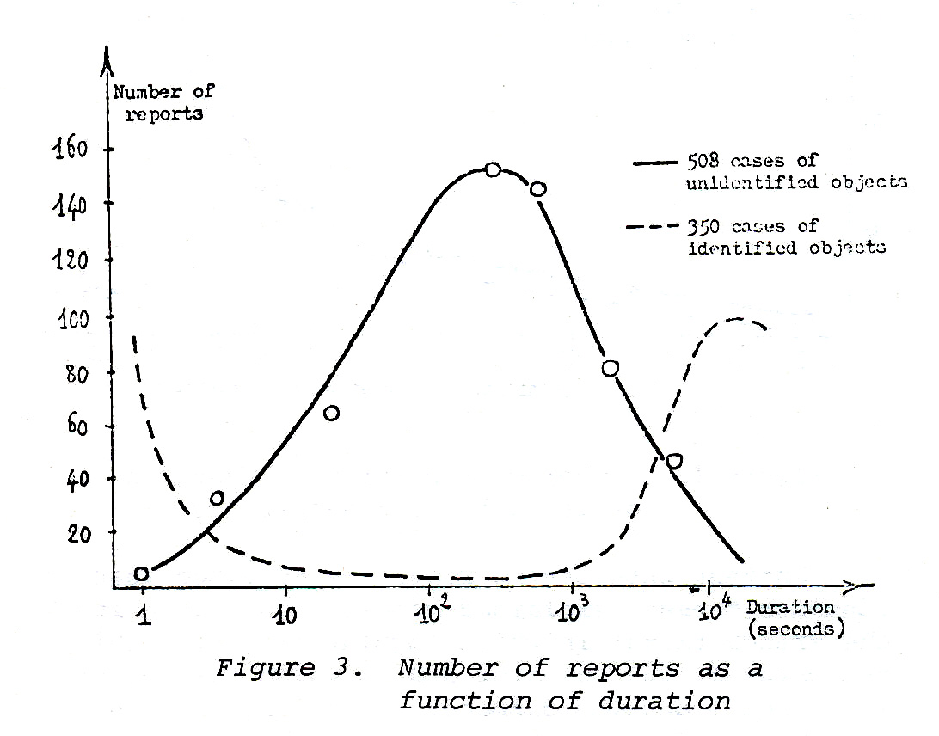

identified), we obtained the curve shown in Figure 3 as a dotted line. Furthermore, this is a worldwide result, as shown by statistics based on 135 French cases and 373 non-French cases and plotted on Figure 4.

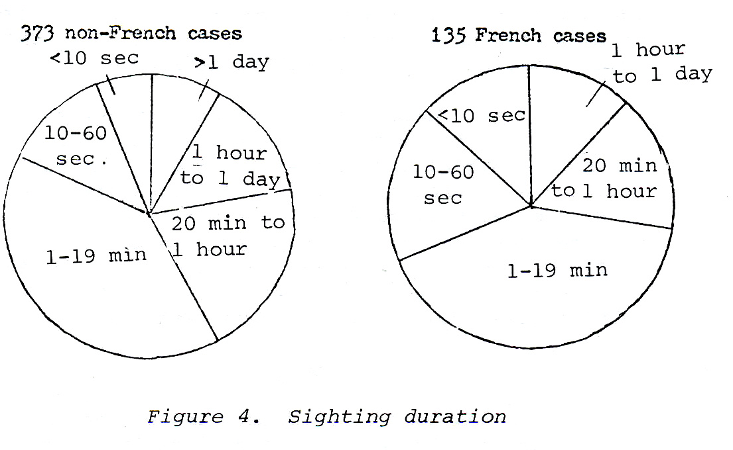

Another important parameter, shown in Figure 5, is that of the distance (as calculated by triangulation) between the observers and the source of the phenomenon. This parameter can only be computed in that subset of the reports which come from witnesses separated in space and observing the same phenomenon. Generally such reports have come from military or police sources. (Examples are found in references 4, 6, 8, 9, 15, 16, and 18.)

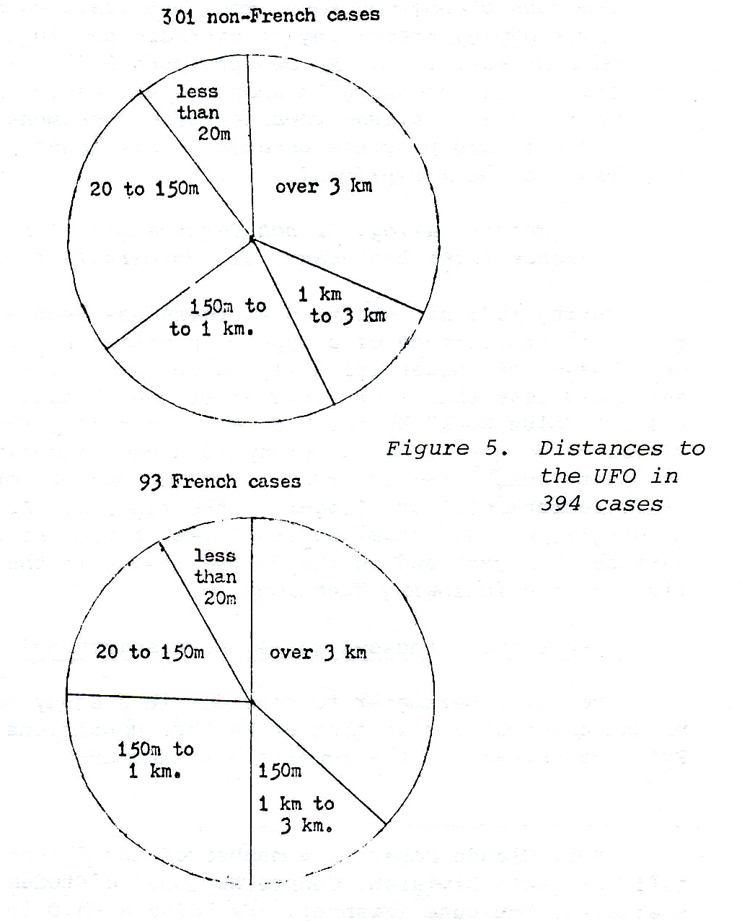

To summarize, we are faced with the problem of finding a phenomenon X that can present simultaneously the three patterns shown in Figures 6 a, b, and c. The authors have not found any identifiable phenomenon that meet these three criteria. At this point, it is appropriate to ask more precise questions about the conditions of the close encounters with the phenomenon (type I reports) and about the witnesses who have made such reports. Finally, we will present some preliminary findings regarding the magnetic properties of the phenomenon.

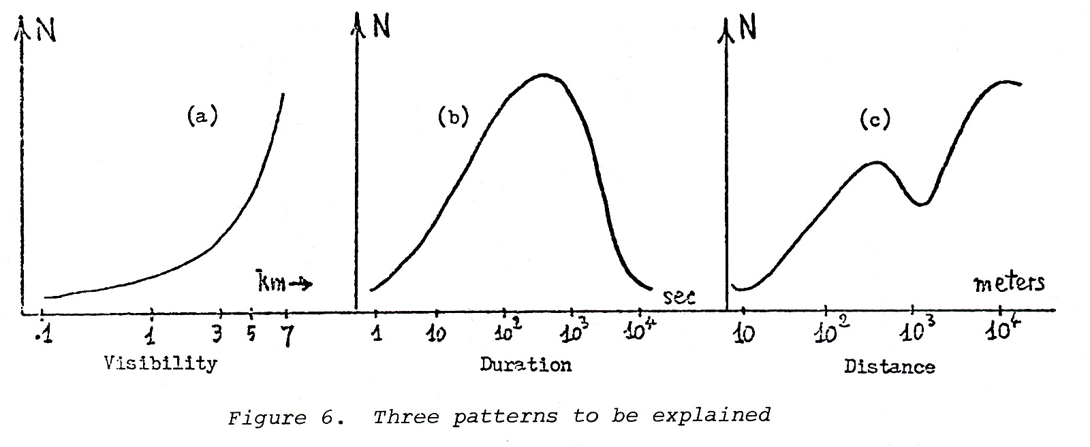

3. Under what conditions is the phenomenon encountered at close range?
One of the most stable patterns in the study of close encounters with the phenomenon (type-I cases*) has been found in the distribution of such reports as a function of time of day. First published in 1963, this pattern can be verified on the basis of worldwide catalogues of type-I sightings. It shows no significant variation in old and recent cases and even yields the same distribution when a sample of previously unreported cases is obtained from a country with low awareness of the phenomenon (Figure 7).

Typically, the number of type-I reports is very low during the day. It starts increasing about 5 p.m. and reaches a maximum about 9 p.m. It then decreases until it reaches a minimum at 1 a.m. It rises again to a secondary maximum at 3 a.m. and returns to a low level at 6 a.m. Such a pattern suggests that the decrease in reports of close encounters between 11 p.m. and 2 a.m. may simply be due to the fact that the number of potential observers falls drastically as most people spend these hours at home.

_______________________
* In the classification used here, type-II reports correspond to cases in which secondary objects are generated by a flying object, type-III to cases in which the object's trajectory has a singular point, and type-IV to cases in which the trajectory is continuous across the sky.
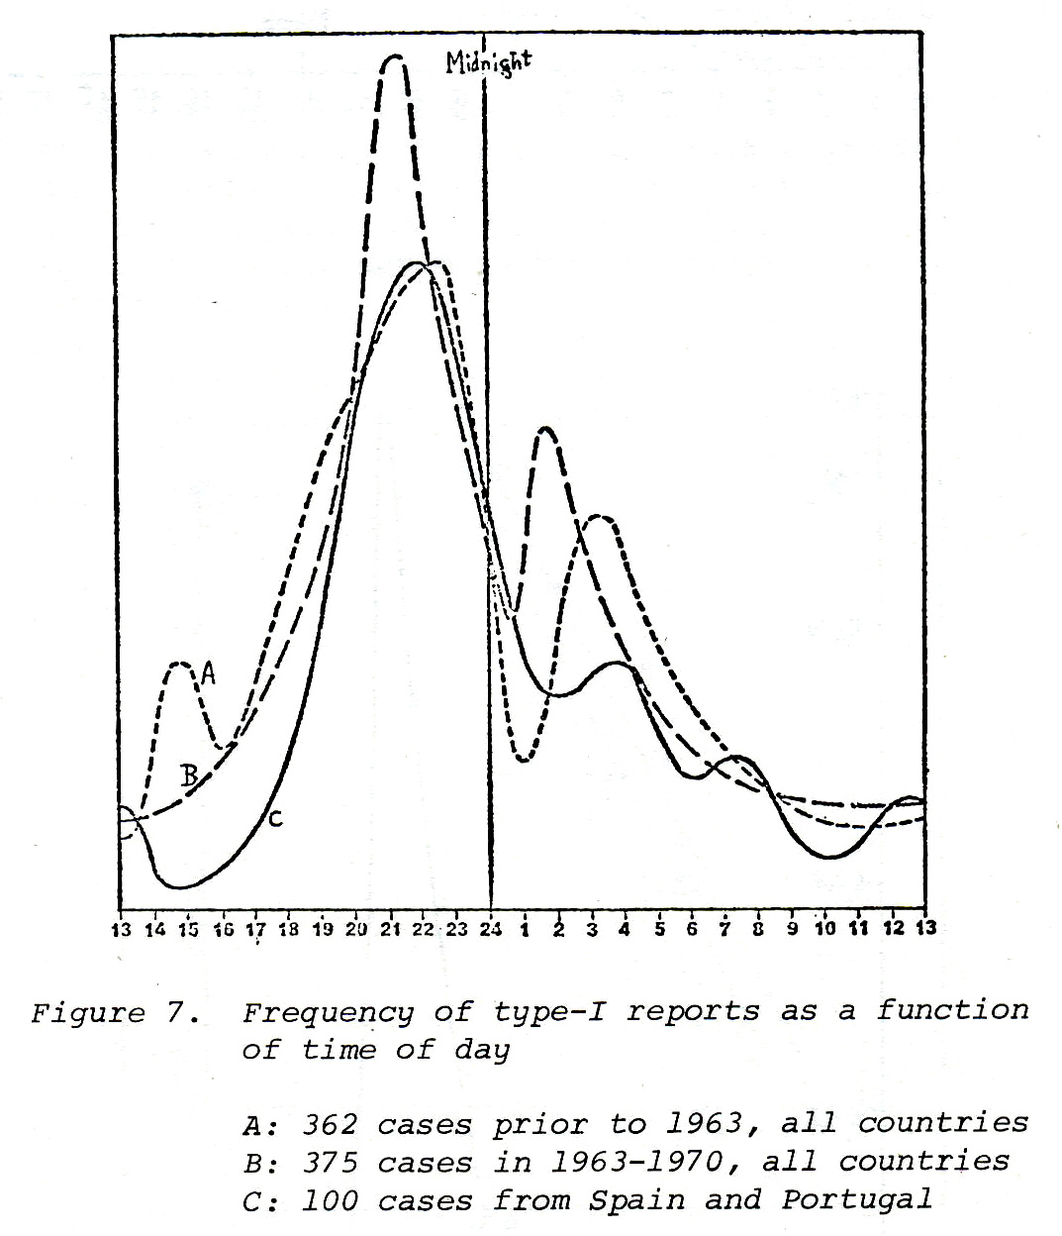

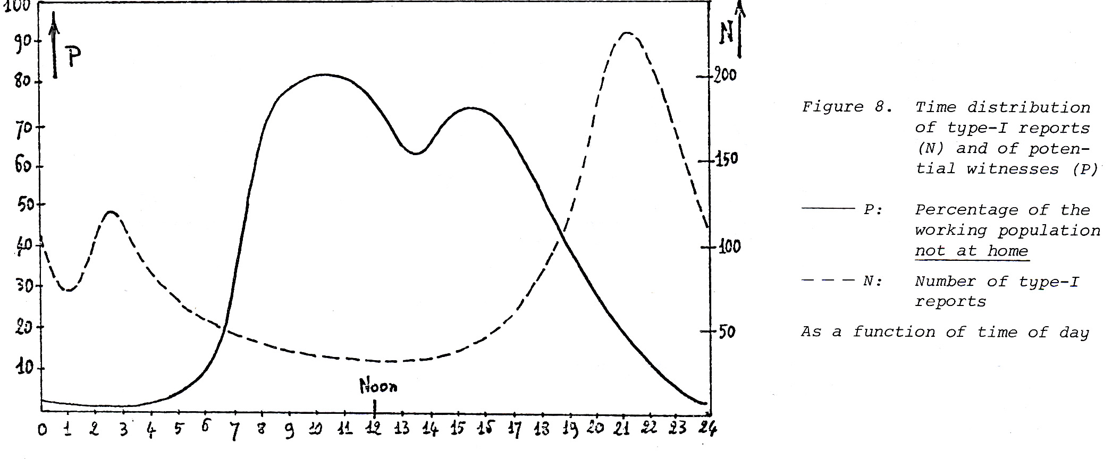
The result of this calculation is shown in Figure 9. (Nc represents the number of type-I reports we would have in our files if people did not go home at night.) The ratio of Nc to N is about 14 to 1. In other words, all other factors being held constant, witnesses are only in a position to observe one in fourteen close approaches of the phenomenon to the surface of the earth. In order to generate the 2,000 close-encounter observations we have in our files, the phenomenon would have had to manifest itself close to the ground 28,000 times during the time interval and in the regions considered here.

We must next pose the question of the nature of the sites where such close approaches take place. An earlier publication (16) noted that, in France, such observations were not found in areas of high population density. This finding is substantiated by the statistics of Figure 10, showing that in approximately 70 percent of the cases, the site of the close approach is a relatively deserted or isolated area. If we pursue the hypothesis that the phenomenon is caused by real objects, then a multiplying factor for population density should be applied to the 2,000 close encounter observations mentioned above. However, we still know too little about detailed patterns followed by the phenomenon to estimate this factor.

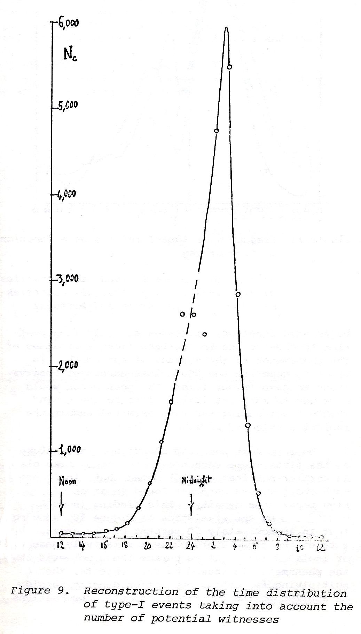

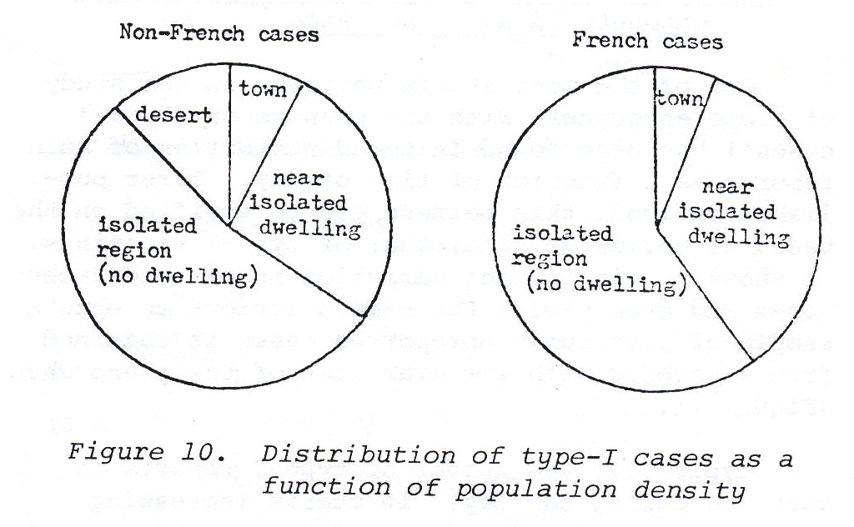

4. What are the numbers and the ages of the witnesses?
A catalogue of 923 cases of type-I reports in the period 1868-1968 contains 878 incidents in which the number of witnesses in the group is given.
Figure 11 gives the distribution of these witnesses tabulated according to the time interval of the sightings.
It can be seen from this table that only slightly more than half of the cases involved witnesses who were alone at the time of the sighting, and that this proportion has been stable over the years.
The age of the witnesses, on the other hand, is known in 147 instances. This information is reflected in the "age pyramid" shown in Figure 12; attention should be called to the fact that we have a paucity of reports from adults in the age bracket of 20 to 40, presumably because they would be most likely to be professionally harmed by the ridicule associated with a report of an unidentified phenomenon. A detailed study of age distribution in old and recent cases has failed to yield any significant difference. The phenomenon does not seem to be associated preferentially with a particular generation.

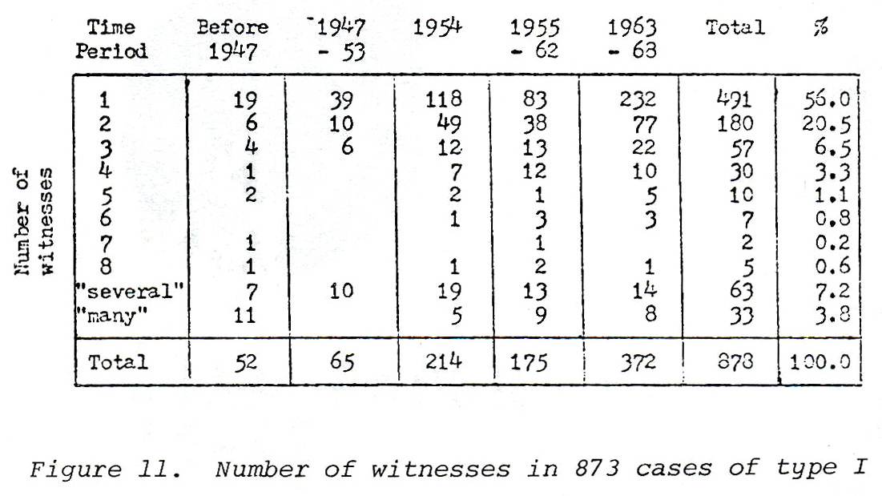

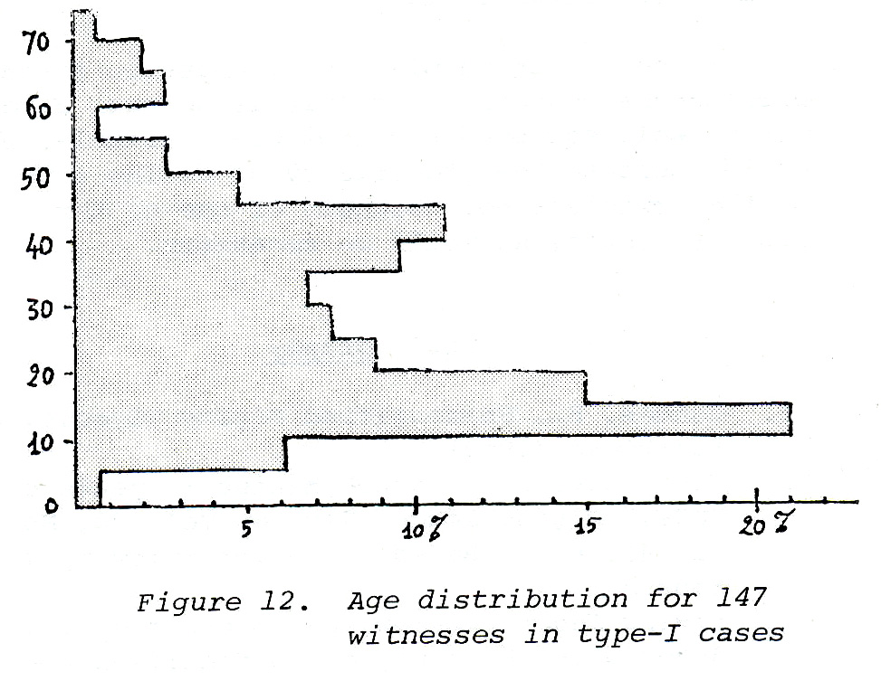

We are led to the conclusion that there is nothing abnormal about the age distribution and group membership of the witnesses of such events, which follow patterns that can be explained from sociological factors alone. The only deviation from the expected norm is the lack of reports from young adults, presumably due to fear of ridicule.

5. Can the observations be correlated with measurable physical events?

Secondary effects observed in connection with UFO phenomena are too varied and numerous to be summarized here. They have been discussed in some detail by several authors (4, 5, 6, 7, 9, 12, 13).
The most interesting of these effects from a physical point of view have been electromagnetic in nature and deserve to be investigated in detail. Geophysical researchers use an existing world-wide network of stations, which record, night and day, the fluctuations of the earth's magnetic field. In France, such a station exists at Chambon-la-Forêt, about 30 kilometers northeast of Orléans. This station has been recording the three components of the field since 1886, with about 1 gamma accuracy and a bandwidth of a few Hertz. We have, therefore, analyzed the UFO eye-witness accounts emanating from an area around Chambon-la-Forêt (10).
In examining these records, we can limit ourselves to a particularly representative period of UFO observations: in this case, the year 1954. (This year alone covers 23 percent of French observations for the period 1944-1971.)
The results show a good correlation between the two phenomena for the month of October. This can be more carefully examined by the analysis of the distribution of witnesses' UFO accounts each day during October.

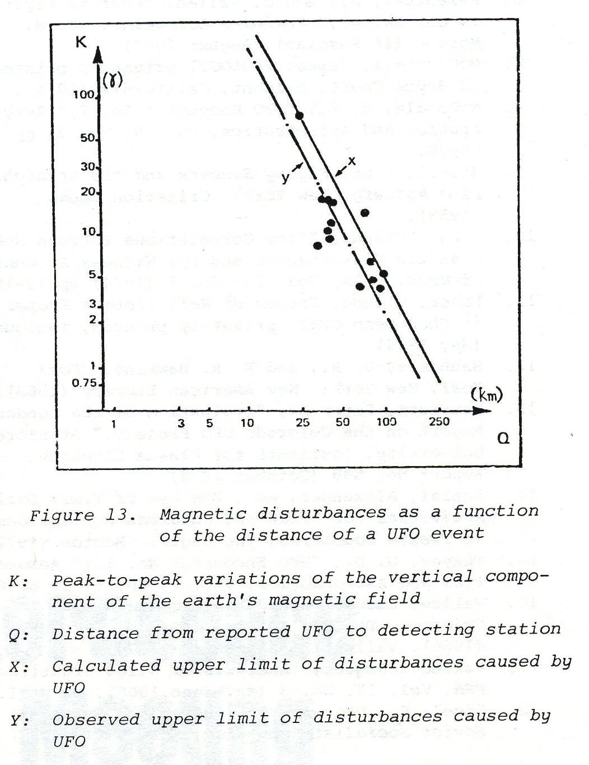

If we limit ourselves to the period between 1 and 18 October, which is the most remarkable for UFO observations, we can calculate a correlation coefficient of UFO observations with declination disturbances of 0.034 and a correlation coefficient with the vertical component of 0.58 which is far from negligible.
On the basis of these same data, a very crude estimate of the upper limit of magnetic disturbances caused by UFOs gives peak-to-peak values of 10 gammas for the field vertical component when a UFO is observed at 40 km from the measuring station.
This distribution leads us to think that the magnetic field produced by the UFO could be 150,000 ampere turns per meter in its immediate neighborhood (Figure 13).
The complete study, which has been published in more detail elsewhere (10, 11), led to the following conclusions:
- The method used here looks as if it might be very useful for an objective approach to the study of the phenomena. The analysis would have to be considerably enlarged, using a greater number of observation reports, associated with several geomagnetic recording stations, in order to obtain results of better quality.
- The detection of UFOs by magnetic disturbances seems possible, but only if several automatic, well-equipped stations are available, which would increase the probability of seeing a UFO pass in the immediate neighborhood of one of them. At least ten stations would be necessary.

Bibliography
Condon, E., Unidentified Flying Objects, Bantam Books (1969).

Creighton, G., "French Minister Speaks on UFOs," Flying Saucer Review, Vol. 20,
No. 2 (1974), p 3. Based on an interview by J. C. Bourret. (Flying Saucer Review, an international journal devoted to the study of unidentified flying objects, is edited by Charles Bowen, P.O. Box 25, Barnet, Hertx. ENS 2NR, England).

Hynek, J. Allen, The UFO Experience—A Scientific Study, Chicago: Regnery (1972) and Ballantine paperback (1974).

Jung, C. G., "Flying Saucers--A Modern Myth," in his Complete Works, Princeton University Press.

Kazantsev, A., and J. Vallee, "What is Flying in our Skies?," Tekhnika Molodezhi, No. 8,
Moscow (in Russian) (August 1967).

McCampbell, James, UFOLOGY, privately printed, 12 Bryce Court, Belmont, California (1974).

McDonald, J. E., "UFO Encounter No. I," Aeronautics and Astronautics, Vol. 9, No. 7, pp 66-70.

Michel, Aimé, Flying Saucers and the Straight Line Mystery, New York: Criterion Books (1958).

Poher, Claude, "Time Correlations between Geomagnetic Disturbances and Eye-Witness Accounts of UFOs," FSR, Vol. 20, No. 1 (1974) pp 12-16.

Poher, Claude, Etudes et Réflexions à Propos du Phénomène OVNI, privately printed, Toulouse (May 1974).

Saunders, D. R., and R. R. Hawkins, UFOs? Yes!, New York: New American Library (1968).

Sturrock, Peter A., "Evaluation of the Condon Report on the Colorado UFO Project," Stanford University, Institute for Plasma Research, Report No. 599 (October 1974).

Szalai, Alexander, ed., The Use of Time: Daily Activities of Urban and Suburban Populations in Twelve Countries, The Hague: Mouton (1972).

Thayer, G. D., "UFO Encounter No. II," Aeronautics and Astronautics, Vol. 9, No. 9, pp 60-64.

Vallee, Jacques and Janine, Challenge to Science: The UFO Enigma, Chicago: Regnery
(1966), Ballantine paperback (1974).

Vallee, Jacques, "Analysis of 8,260 Sightings,' FSR, Vol. 14, No. 3 (May-June 1968), pp 9-11.

Zigel, F., UFO Observations in the Union of Soviet Socialist Republics, Moscow (1974).

_______________________

