A System of Classification and Reliability Indicators
for the Analysis of the Behavior
of Unidentified Aerial Phenomena
Jacques F. Vallee (*)

When faced with hundreds or even thousands of reports of unusual aerial phenomena, no serious researcher can undertake any study or hazard any hypothesis before analyzing the patterns buried in the reports. These patterns only reveal themselves when the witnesses’ accounts are classified into major categories whose prevalence and recurrence can then be computed. This is a time-consuming task that demands a great deal of rigor, which explains why so few research organizations have done it consistently. In our own work, we have used such classification systems for many years, in the context of very different data sets. We have learned from early mistakes, and this effort has led us to propose the current scheme based on the reported behavior of the object. The purpose of this paper is to clarify the system and its practical use.

Early History

Any classification system for anomalous reports needs to start from the observed behavior of the phenomenon rather than any subjective feature linked to the observer. At the same time, the classification system must be able to support the testing of hypotheses by researchers coming from “skeptical” as well as “proponent” positions with respect to popular interpretations of the phenomena in question. And it must not presuppose any particular theory.
To my knowledge, the first classification system of this type that was applied to “UFO” phenomena grew out of my work in 1961 and 1962 with Aimé Michel and Dr. Pierre Guérin in Paris. I proposed to separate the massive collections of French sightings – notably those from the 1954 wave – into four major categories. Briefly summarized, they encompassed the following:
------------------------------
(*) A first version of this article was published in my book Confrontations (New York: Ballantine, 1990). The system we developed in France was described in Challenge to Science (with co-author Janine Vallee, Chicago: Regnery, 1966) published in French the previous year under the title Les Phénomènes Insolites de l’Espace (Paris: La Table Ronde).

Type I, which was further divided into three subgroups, gathered all the “landing” reports that Dr. J. Allen Hynek would later call “close encounters.” It may be hard for the modern reader to realize that until the late Sixties, American ufology did not admit that such reports existed. Among the major civilian organizations, only APRO, headed up by Jim and Coral Lorenzen, recognized their significance. The Air Force’s Project Blue Book automatically sent landing reports into the psychological file.
Type II reports were observations of the “cloud cigars” so prevalent in Europe in 1954, and whose apparent role in the development of major waves had been pointed out by Aimé Michel (+). Such reports have become rare in the following years, and there is no longer a justification for this category.
Type III reports involved objects that exhibited a discontinuity in their trajectory; either they stopped and hovered, or they came towards the ground with a falling leaf motion before resuming their flight, or they performed some maneuver that identified a specific point in space and time. This was important for us at the time because we were compiling a catalogue with longitudes and latitudes, recorded with as much precision as possible.
Type IV, by contrast, gathered all cases of objects in uninterrupted flight.
This classification served its purpose for many years. It enabled us to uncover specific time and space patterns for various types of behavior, notably the “law of the times” for landing reports.

Hynek’s classification
In 1972, on the basis of the work we had done together since the mid-sixties, Hynek built upon my earlier classification when he proposed (*) to divide all reports into two groups: the short-range sightings which corresponded to my “Type I” and which he called Close Encounters
----------------------------
(+) In Flying Saucers and the Straight-Line Mystery, NY: Criterion, 1958.
(*) In his classic book The Ufo Experience, Chicago: Regnery, 1975.

(a term later immortalized by Steven Spielberg); and the objects observed “at some distance,” which he further divided into three categories:
NL for Nocturnal Lights
DD for Daylight Disks
RV for Radar-visual

Hynek was well aware that these divisions were arbitrary, and he remarked himself that the categories “may not be mutually exclusive.”
The major contribution of Hynek’s classification was the clarity with which “landings” were now defined:
CE1 was the class of objects seen on the ground or close to the ground
CE2 was the class of reports where physical effects or traces were reported
CE3 was the class of reports where “occupants” or “entities” were present, a
category from which he excluded claims of repeated contact.

These definitions have stood the test of time. In recent years a new category has been invented. Called CE4, it encompasses the abduction reports in which the witness claims not only to have seen occupants but to have extensively interacted with them inside their vehicle or craft. Rather than taking an abduction claim as our reference, we prefer to use the term “reality transformation.”
Serious complications arise, however, when one tries to use Hynek’s categories of nocturnal lights, daylight disks and radar-visual cases, especially when the screening process works from a computerized database, as it needs to do in any sophisticated effort to attack the problem. Not only do these categories overlap (a “disk” may be seen in daylight and also tracked on radar, for instance) but many reports cannot be placed into any of these classes: What happens if an object is seen at night, but is not a light? Or when an object seen in daylight is not shaped like a disk? What about reports of objects seen at dusk or dawn?
The work we have done in recent years with four parallel computer catalogues has led us to suggest a practical solution to the problem.

A Classification System based on the Behavior of the Phenomenon
The major flaw in previous classification systems is that they take as their basis the position of the observer, which is arbitrary and changing, rather than the reported behavior of the phenomenon from which one could draw important conclusions in terms of patterns. In other words, it may be interesting to know that a particular witness described a disk while another saw a triangle or a square, but this is a purely subjective item that is a function of the percipient, not a behavioral attribute of the phenomenon: one person’s “disk” is another person’s “ball of light.” It is more relevant to know such stable facts as whether or not the object presented a discontinuity in flight or came close to the ground, items for which there is more consistent agreement.
Another flaw in existing systems is that they are too complicated and require constant reference to codebooks with overly-detailed definitions that are time consuming and error-prone.
In order to encompass the full range of phenomena one finds in the reports from witnesses, it is important to acknowledge that what most people call “UFOs” are related in significant ways to other anomalies. It is the rule, rather than the exception, to find the observation of a flying object preceded or followed by other unusual phenomena. For that reason, I find it useful to begin with a classification of Anomalies that parallel Hynek’s close encounter designations:
AN1 events are anomalies like amorphous lights or unexplained explosions in the sky, that do
not have lasting physical effects.
AN2 reports involve lasting physical effects, such as poltergeist phenomena, anomalous
photographs, flattened grass or “apports.”
AN3 cases are anomalies with associated entities. This could involve reports of ghosts, yetis and
other instances of crytozoology, or even elves or spirits.
AN4 designates those anomalous reports in which witnesses describe personal interaction with
entities in the reality of the entities themselves. This includes near-death experiences, claims
of religious visions and some cases of out-of-body experiences.
Finally, we place under AN5 the cases in which anomalous injuries or deaths are reported, such as unexplained wounds or spontaneous combustion. Claims of permanent healings would also fit within this category.
We now come to the UFO reports themselves, which I will divide, following Allen Hynek, into close encounters and distant sightings.
I see no reason to change anything to the classification of close encounters that is in current use, from CE1 to CE4, although Dr. Hynek was not responsible for creating the CE4 category and was not especially happy with this extension of his work. In recent years the need has arisen for a new category, CE5, which encompasses cases of close encounters in which the witnesses have suffered permanent injury or other physiological or pathological effects.
The distant sightings are classified here according to the apparent behavior of the object under two general categories, namely MA for “maneuver” and FB for “flyby.” Within these categories, the sub-definitions follow those of close encounters.
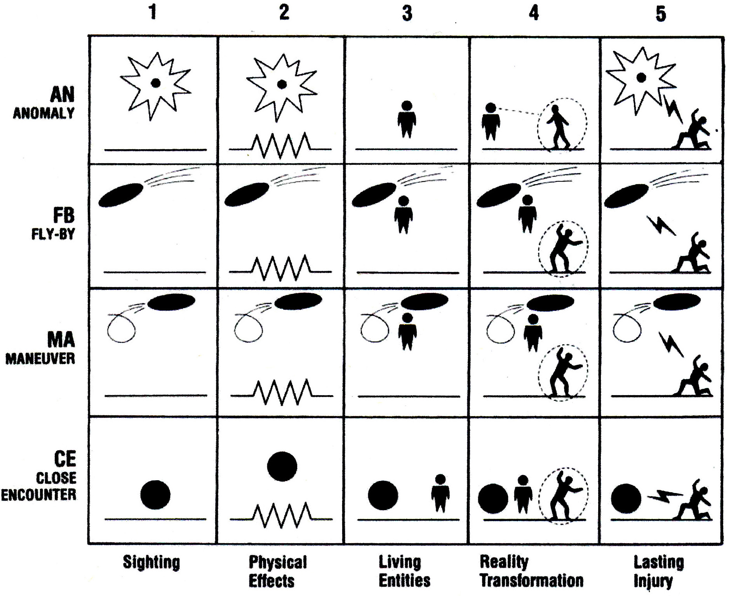

Maneuvers

MA1 gathers those observations that involve an object with a discontinuous trajectory such as a
drop, a maneuver, a hovering stop, or a loop.
MA2 includes those cases that give rise to physical effects in addition to a discontinuity in
trajectory. For instance, an official French report described an object that hovered close to a
town’s photocell, triggering an extinction of the street lighting system.
MA3 contains the cases of objects with discontinuous trajectories when beings are observed on
board.
MA4 covers instances of maneuvers accompanied by a sense of transformation of reality for the
percipient.
MA5 involves reports of permanent injury or death related to a maneuvering object in the sky.

Flybys

The classification continues with the “Flyby” cases:

FB1 is a simple sighting of an unexplained object “flying by” in the sky without discontinuity. It
is the most-frequently reported category.
FB2 involves cases of flyby with physical evidence, such as a recorded sound or radar tracking.
FB3 gathers cases of flyby where report of an object is accompanied by the observation of beings
on board. Although rare, this type of sighting is occasionally reported.
FB4 represents a flyby in connection with which the witness claims he or she has undergone a
transformation of reality.
FB5 has to do with cases where witnesses of a flyby suffer serious injuries, as in the
well-documented “Cash-Landrum” medical incident near Houston, Texas, where two
women and a boy were hurt as an unexplained, very bright object flew above them without
stopping.

These four major categories, with their five variants, define a very simple system of 20 codes that are easy to remember and to handle statistically since very little overlap can occur among the categories. An additional benefit of a behavior-based classification system for the analyst is found in the fact that certain hypotheses to explain the observations are specific to each category. For instance, FB events should be examined for explanations involving meteors or airplanes, which are unlikely to apply to CE cases.

The SVP Credibility Rating

No classification system is complete without a way of assigning credibility or “weight” to an observation. While such a procedure is an integral part of any intelligence evaluation, UFO researchers have rarely applied it in support of their work. (*) The system needs to be simple enough to be applied quickly, and with enough mnemonic value to insure it does not require constant reference to a thick codebook.

In our own work we now use a simple, three-digit code to indicate the weight of a UFO report. Each of the three digits has a value from zero to four, as follows:

The first digit, “S” indicates the reliability of the source:
- is used for an unknown source, or an unreliable source
- is for a report attributed to a source of unknown reliability
- is from a credible source, second hand
- is from a credible source, first hand
- is a firsthand personal interview with the witness, by a source of proven reliability

(*) A notable exception is the “quality index” proposed by Spanish researchers Ballester-Olmos and Guasp, but it may be too detailed for practical use on large databases.

The second digit, “V” indicates whether or not a site visit took place:
- is used when there was no site visit, or the answer is unknown
- indicates a visit by a casual person unfamiliar with such phenomena
- flags a site visit by a personal familiar with the range of phenomena
- is a site visit by a reliable investigator with some experience
- indicates a site visit by a skilled analyst

The third digit, “P” indicates the probability of natural explanations:
0 is used when the data is consistent with one or more natural causes
1 means that a natural explanation only requires slight alteration of the data
2 means that a natural explanation would demand gross alteration of one parameter
3 means that a natural explanation demands gross alteration of several parameters
4 means that no natural explanation is possible, given the evidence

Thus a rating of 222 or better (meaning that each of the three digits is 2 or higher) indicates events reported through a reliable source, in which a site visit has been made, and where a natural explanation would require the gross alteration of at least one parameter.

Equipped with this reliability code and the classification described above, it is possible to start making sense of the patterns extracted from the mass of unusual aerial phenomena reports.
This system is now in use in all our catalogues. It has also been used consistently by several major external studies, notably by CUFOS in their UFOCAT catalogue, by the National Institute for Discovery Science (NIDS) in its private database, and by the French study of pilot sightings conducted by M. Dominique Weinstein in connection with the GEIPAN (Groupe d’Etudes et d’Information sur les Phénomènes Aériens Non-identifiés) in connection with the CNES in Paris. Thus it is becoming possible to compare statistical data in cross-indexing among several databases, a significant first step towards international cooperation in the study of this puzzling phenomenon.

San Francisco, April 2007

